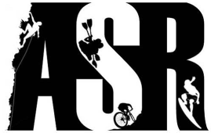

Adrenaline Sports Resort

WEBSITE Report #1

Lawrence Tam | Web Development Intern | January 30th, 2019

Table of Contents:

1. Branding
2. Current State of Website + Commentary
3. Improvements to be Made
4. Branding

Color Palette:

Primary -- (Alizarin Red) : #D91E36 : rgb(217,20,54)

color red

Red. The color red has a reputation for stimulating adrenaline and blood pressure. – Google

Secondary -- (Safety Yellow) : #EED302 : rgb(238,211,2)

Have fun while we take care of your safety

Neutral -- (Black) : #FFFFF : rgb(0,0,0)

(Silver) : #C3C3C3 : rgb(195,195,195)

­­­ Because white is boring

Fonts:

Primary – Montalban (bold display face)

<https://www.dafont.com/montalban.font>

* “based heavily on the title and end-credits from the legendary Star Trek II: The Wrath of Khan movie” – taken from webpage

Secondary – Dubai

<https://dubaifont.com/>

* young, dynamic, full of passion and energy

* sans-serif (IMPORTANT for digital readability)

1. Current State of Website + Commentary

* Bug: Dubai Font is not applied to the website. Must be an oversight in the CSS file

Technology Used:

- Adobe XD

- HTML, CSS, Javascript

- ReactJS, NodeJS

- GoDaddy, Cpanel, PHP plugins

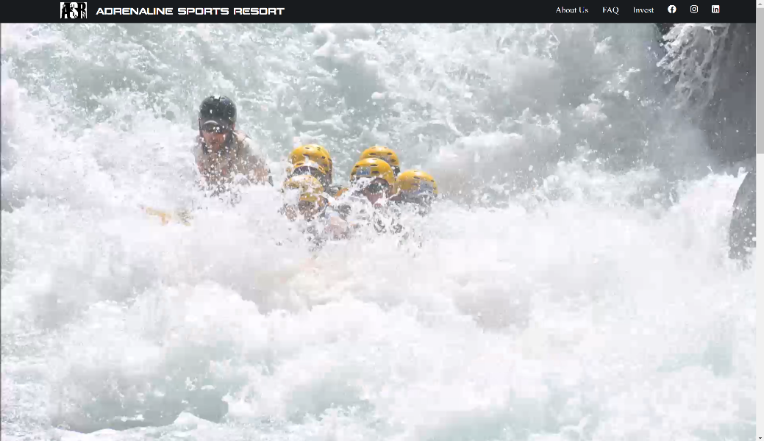Home_1

* [Top Navigation Bar]

- Static

- Navigation

[Home] [About Us] [FAQ] [Social Media]

* [Welcome Banner]

- Dynamic GIF

- Choppy

- Unedited

Improvements:

- collapsing nav bar

- get a smoother video

-- OR get a nice graphic

- move social media to footer

- extra points: stop the video loop after one render, dim it, and add the ASR logo on top to look AESTHETIC

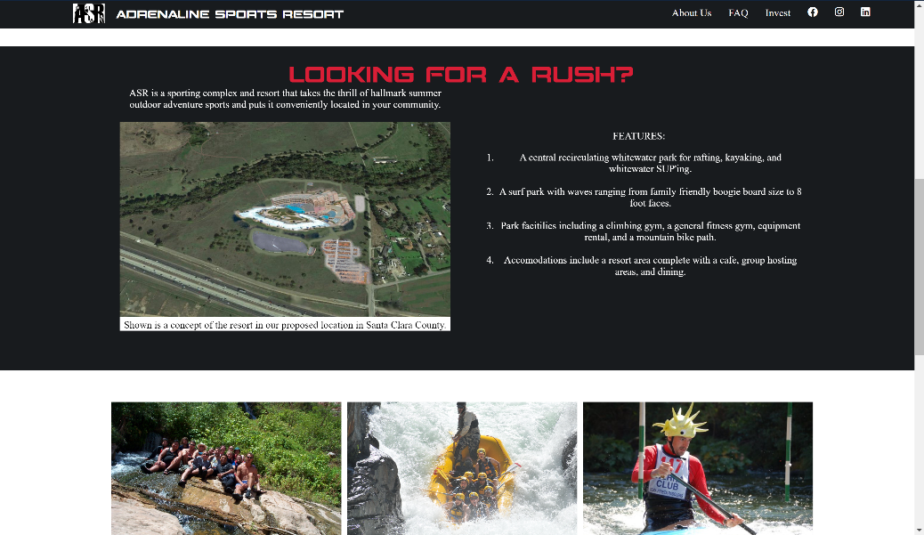Home_2

* [Brand Description]

- Text Description

- Image with subtext

- Key features list

* [Navigation Banners]

- Get Involved

- Get Stoked

- Contact Us

Improvements:

- better spacing

- side-scrolling features list

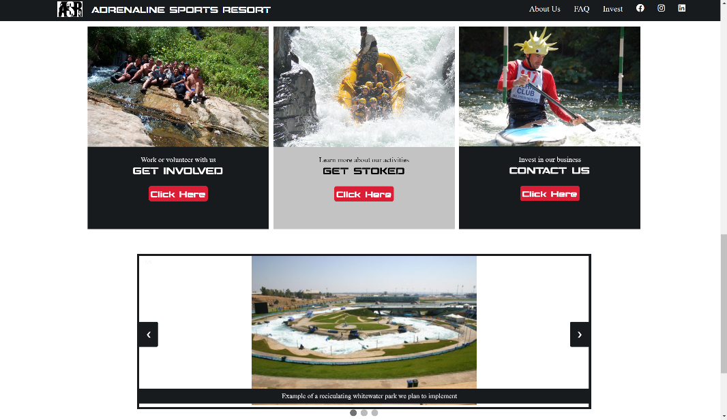

Home_3

* [Navigation Banners]

- Get Involved

- Get Stoked

- Contact Us

- highlight on hover

* [News slideshow]

- filler pictures

Improvements:

- fill white space in slideshow

- can be achieved by having images of the same dimensions

- remove “click here”, button, and create a highlighting interaction to the user, signifying a navigation link

- extra points: replace the image with a static image, then replace the image with a gif on :hover

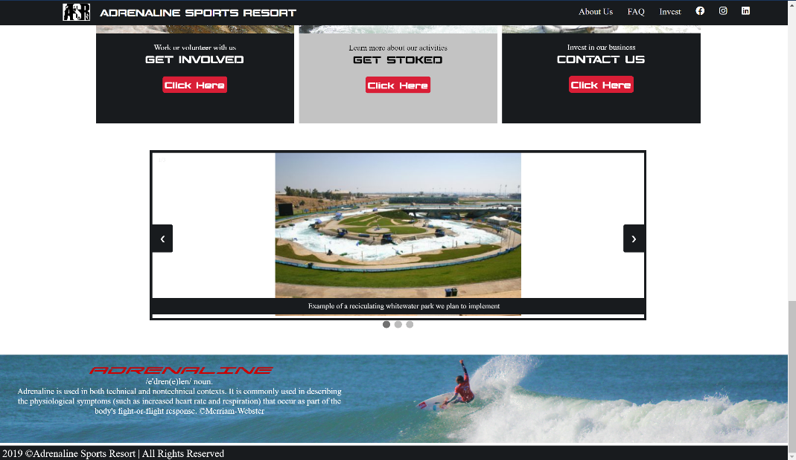

Home_4

* [Brand Description]

- Text Description

- Image with subtext

- Key features list

* [Footer]

- Adrenaline Definition

- Stock ocean surfer

- Copyrights

Improvements:

- the red font in the footer clashes with the blue background

- Solution: add an opaque/neutral background to bring out the text

- move social media options here – apparently it’s a standard to have them at the footer

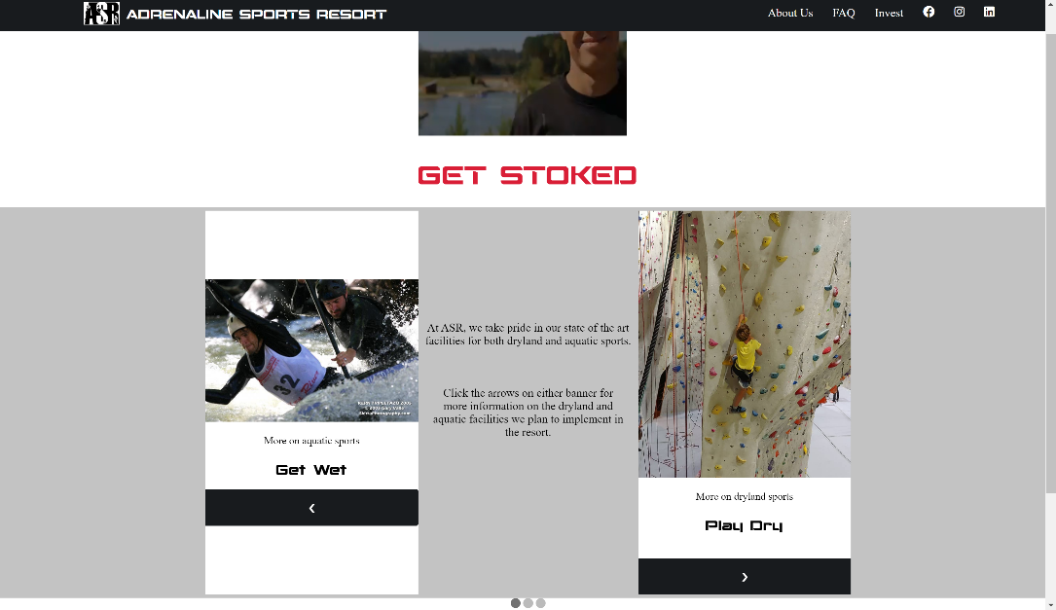Get_Stoked_1

* [Brand Description]

- Text Description

- Image with subtext

- Key features list

* [Footer]

- Adrenaline Definition

- Stock ocean surfer

- Copyrights

Improvements:

- Obvious spacing issues

- The gray background isn’t cutting it. We should split the “get wet” and “play dry” into two separate divs, each with their own sliders

- This page feels unnecessary. I believe we should move it to the homepage, replacing “looking for a rush”, because it is a better alternative

- the video is too small, and doesn’t represent ASR.

- solution: make a video representing ASR, could just be a powerpoint or brief by Big Man Grigsby

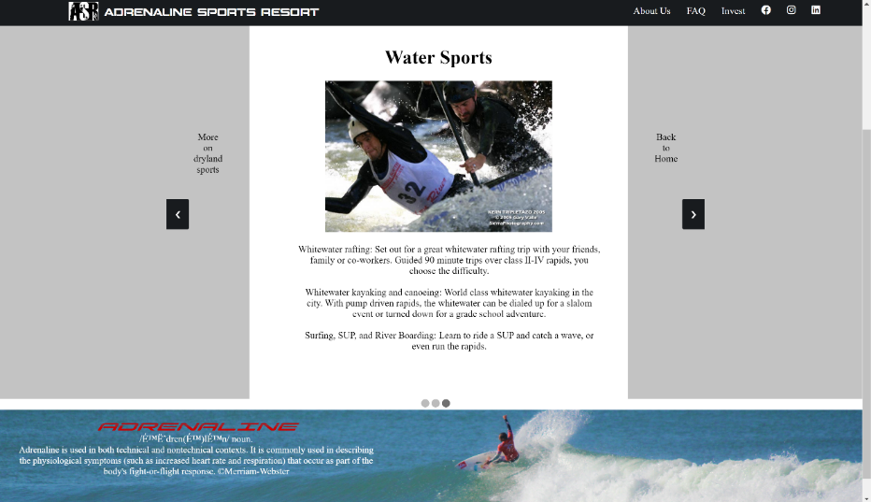Get_Stoked_2

- refer to get_stoked_1

1. Improvements to be Made
2. Compress all media for faster rendering
3. Figure out a solution to the welcome GIF
4. Fix Dubai Font Bug
5. Add Data and Statistics Component for Investors
6. Update UI for the web form page, which lacks any navigation options
7. Design new “Get Stoked” component and move it to the home page
8. Update “Get Stoked” nav link contents to be a detailed description of each component
9. Move social media links to footer
10. Update home page banners for better UI/UX as in its explanation
11. Update Slideshow for UI/UX

- note: try out wordpress or figma for future rapid prototyping and easier development

- use SaSS for CSS